Phylum Arthropoda

Class Crustacea

Isopods
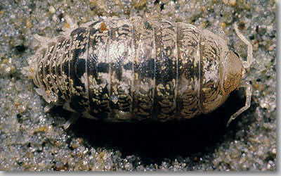
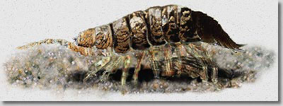
Tylos punctatus, Beach pill bug
http://www.biosbcc.net/ocean/marinesci/03ecology/sblife.htm

Amphipods
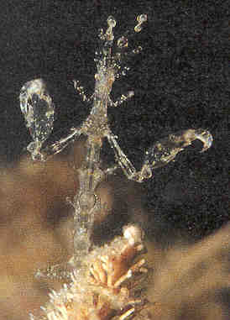
Caprella sp., Hydroid amphipod
http://www.woodbridge.tased.edu.au/mdc/Species%20Register/amphipods.htm

Barnacles
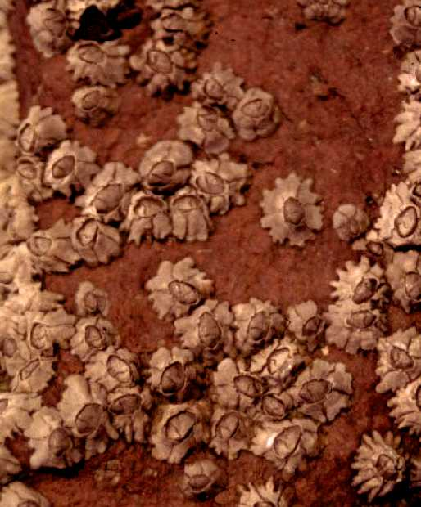
Chthamalus anisopoma, Small barnacle
http://sunflower.bio.indiana.edu/~clively/Research/About%20Chthamalus.html

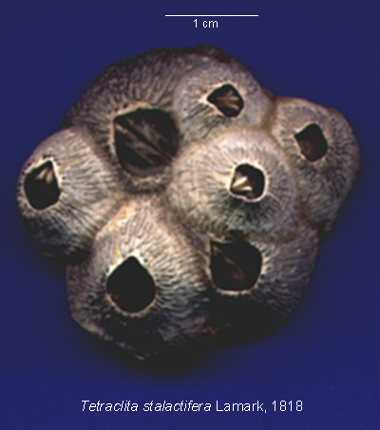
Tetraclita stalactifera, Thatch-roof barnacle
http://www.geocities.com/barnacles_br/tetraclita_stalactifera.html

Shrimp/lobsters
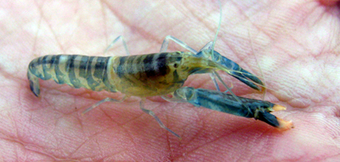
Alpheus sp., Pistol shrimp
http://habitatnews.nus.edu.sg/news/pulauhantu/2004/10/pistol-shrimp.html

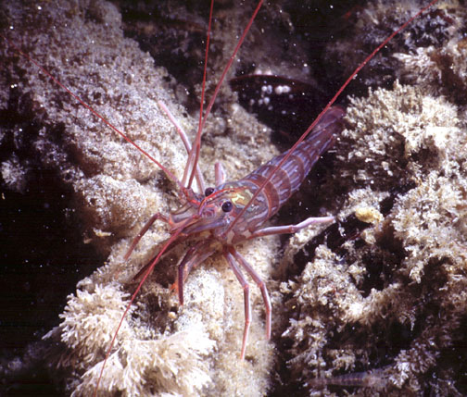
Lysmata californica, Red cleaner shrimp
http://www.divebums.com/FishID/Pages/red_rock_shrimp.html

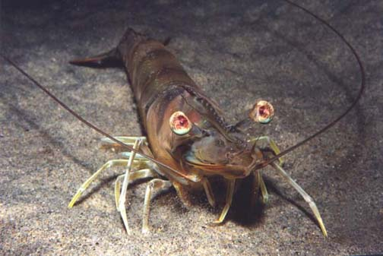
Penaeus californiensis, Brown shrimp
http://www.divebums.com/FishID/Pages/brown_shrimp.html

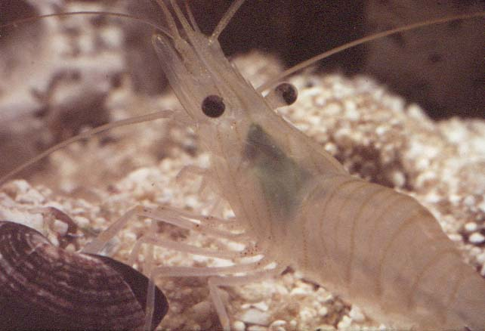
Palaemon sp., Tidepool shrimp
http://ourworld.compuserve.com/homepages/BMLSS/portfol5.htm

Brachyuran crabs (true crabs)
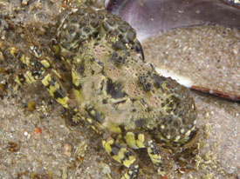
Eriphia squamata, Lumpy-claw crab

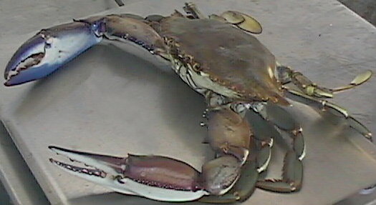
Callinectes bellicosus, Swimming blue crab
http://www.oceantechnology.com/harborgold.htm#

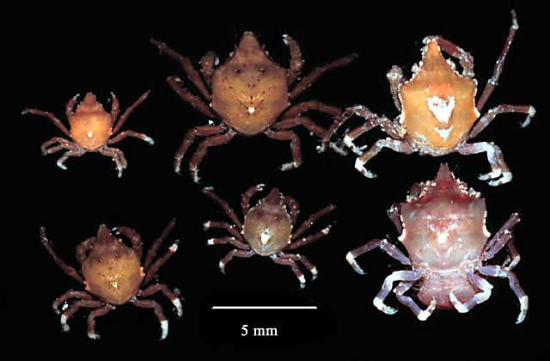
Epialtus sp., Sargassum crab

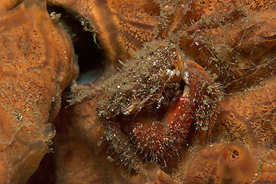
Pilumnus sp., Hairy crab
http://www.edge-of-reef.com/brachiuri/BRAPilumnusen.htm

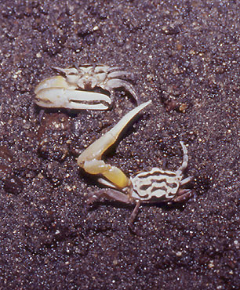
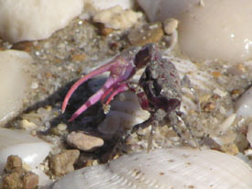
Uca sp., Fiddler crab
http://www.edge-of-reef.com/brachiuri/BRAucaspen.htm

Anomuran crabs (hermit crabs/porcelain crabs)
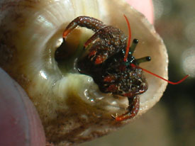
Clibanarius digueti, Red-fingered hermit crab

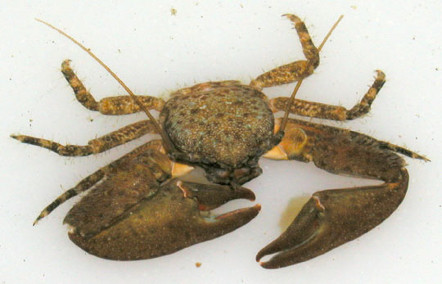
Petrolisthes sp., Porcelain crab
http://www.divebums.com/FishID/Pages/porcelain_crab_cabrillo.html

All other photos from http://dtc.pima.edu/%7Enschmidt/gallery/gallery_index.html

